How to draw Markush structures​

You can define what R1 can be by drawing the substituents in the available space around the backbone:

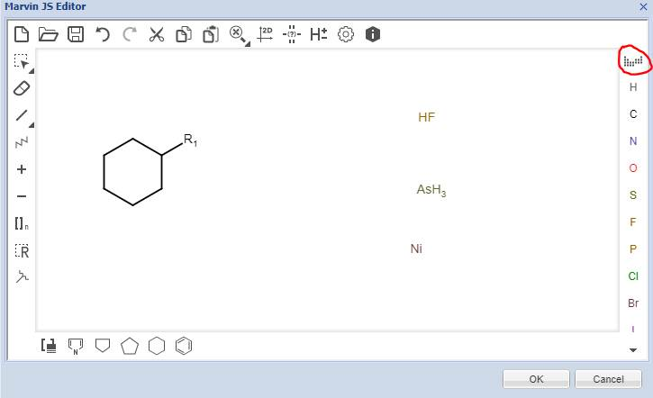

You must define the attachment points of these substituents using the last icon on the left:

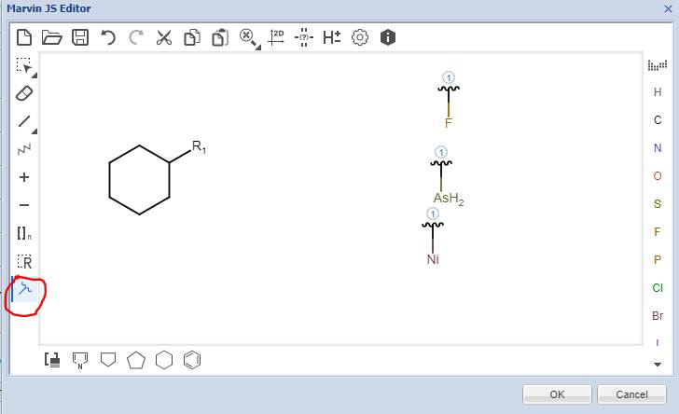

Then select all the substituents by clicking on the R icon again. The system will know that this is your R1:

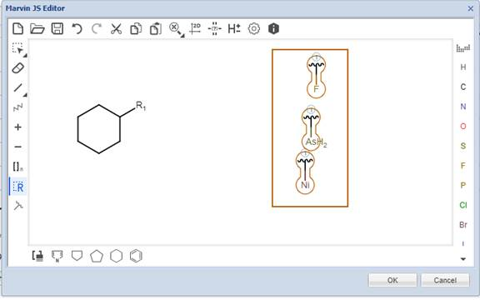

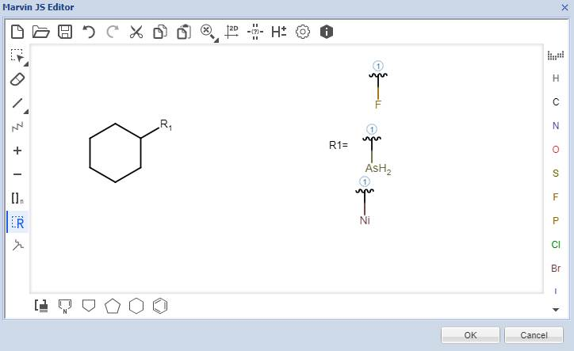

You can repeat those operations to add R2, etc.

